Calculate & Plot the Composite Index
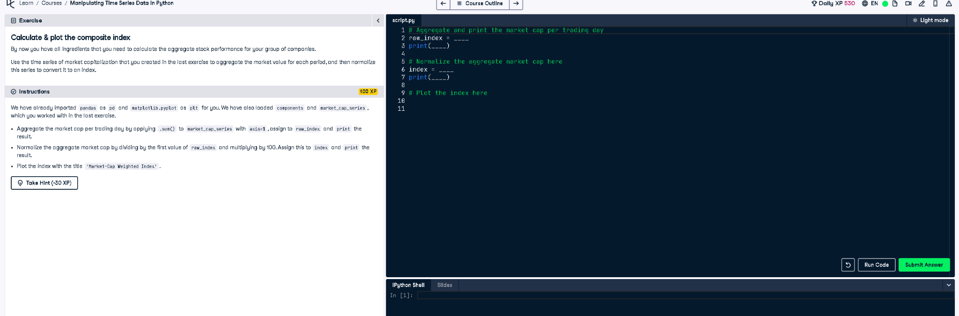

Final Code
# Aggregate and print the market cap per trading day
raw_index = market_cap_series.sum(axis=1)
print(raw_index)
# Normalize the aggregate market cap here
index = raw_index / raw_index.iloc[0] * 100
print(index)
# Plot the index here
index.plot(title='Market-Cap Weighted Index')
plt.show()

Explanation
This code calculates a market-cap weighted index over time. First, it sums the market cap of all stocks per day, then normalizes by the first day's value and scales it to 100. Finally, it plots the index to visualize trends.

